Scott Copley App Review

Daisy the Dinosaur

April 5, 2021

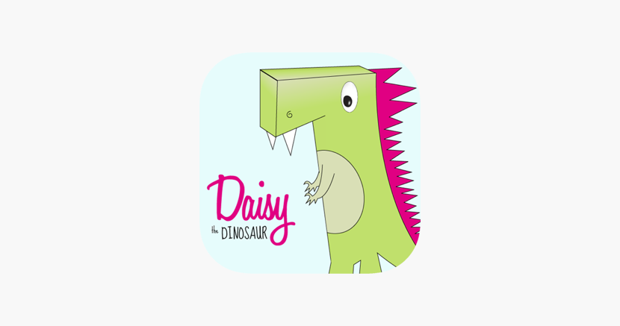

General Information

Offered by the company Hopscotch, Daisy the Dinosaur is a free app, created to introduce young children to coding. Pila, et al., (2019, p. 52) discusses that employment opportunities will increase by 12.5% (500,000 jobs) between 2014 to 2024, yet there may not be enough workers to fill those roles. Daisy the Dinosaur aims to encourage interest in computer science by providing an ideal starting point. According to Lynda.com, “…it’s designed to help very young children learn the simplest of programming concepts…it’s completely free and available for download from the app store.” While using the app, kids may not realize they are working through very simple computer programming since it feels mostly like playing a game. Daisy does not have any visible code, nor does it have much visible information or instructions. The app is designed to run on portable Apple devices (iPhone and iPad) and is available from the Apple app store.

Experiencing Daisy the Dinosaur

Daisy is a cute character (cartoon dinosaur) and uses pleasant colors, with large icons and large buttons, which would appeal to young children. All screens within the app are clean and simple, with the options being generally self-explanatory. Upon opening the app, there are two options: free-play mode and challenge mode. First time users may appreciate the challenge mode since it becomes a bit of a tutorial, starting with the most basic “challenges” such as move forward or backward, and then builds by adding other commands such as jump, spin, etc. After the user successfully completes the steps, a pop-up window appears on the screen to congratulate the player and encourages them to move to the next level. The free-play mode allows the user to code commands and tasks for Daisy to complete however they would like, though it is limited to only nine code commands.

Help and Support

The help features are extremely limited in Daisy the Dinosaur. In the challenge mode, arrows fade in and out to guide the player toward the step they should take. The arrows are helpful, especially for young, pre-reader users. Beyond the arrow prompts, there are no other help options. The simplicity of the app has nullified the need for technical support beyond what Apple provides in the app store, should a user have difficulty loading the app onto their device.

Teaching with Daisy

Daisy offers the most basic entrance into the world of computer programming, and most students will not realize that they are actually coding. Daisy appears to be a fun game, which is a nice way to get children interested in coding without making it feel laborious. According to codemonkey.com, Daisy “uses such functions as conditionals and loops without actually making the child memorize what their names are and rather understanding the logic of how they can be used.” Because Daisy is decidedly very simple, young learners will master it very quickly. While the Apple app store suggests that students ages 5-7 are the ideal age range to use Daisy, even younger learners (ages 3 to 4) are able to open apps on their own, design graphics and tell stories (Neumann, 2017.) Learners who are at the top of the age range will likely master the concepts of Daisy very quickly, and thus become bored after a short time. It will be important for teachers and parents to be prepared to introduce young learners to new apps and challenge them while continuing to stimulate their intellectual curiosity.

Strengths and Weaknesses

Daisy is fun, interactive and uses nice colors and simple graphics to help young learners understand the very basics of code without drawing attention to the reality that they are coding. Pila, et al., (2019, p. 54) emphasizes that if a program or game is not fun for young learners, they will not use it, and therefore the learning opportunity will be missed. Because of Daisy’s very simple design, most learners will learn the skills quickly and be ready for new challenges. One major strength is that Daisy is free to download, and there are no purchases required from within the app. A drawback is that the app it is not offered on Android devices, nor is it available on a PC, which may be a barrier for some families or school districts. Another limitation is that there is no way to save and share what a user has created, making it difficult for teachers to assess student learning. One work-around might be that a teacher asks the student to demonstrate what they have created on their device before closing the app.

Overall Evaluation

Daisy is a fun way to inspire young learners to get into coding. Many students will enjoy having a bit of control over the character while they experiment with the different moves they can create for Daisy. As discussed by Kush (n.d.) “It’s fun to make Daisy move around, and kids may feel empowered as they create simple animations.” Taking into account that the app is free to download, it provides a low-risk, entertaining route to get children interested in code. All things considered, Daisy is an ideal start for children to become skilled coders and computational thinkers.

References

Code Monkey. (n.d.). The best apps to teach kids coding.

<https://www.codemonkey.com/blog/the-best-apps-to-teach-kids-coding>

Kush, J. C. (2021) Daisy the Dinosaur: computational thinking. [PowerPoint slides]

Blackboard@DU. <http://www.duq.blackboard.com>

Lynda from Linkedin (n.d.). Making things move: Daisy the Dinosaur.

<https://www.lynda.com/JavaScript-tutorials/Making-things-move-Daisy-Dinosaur/155284/165454-4.html>

Neumann, M. M., & Neumann, D. L. (2017). The use of touch-screen tablets at home and pre-

school to foster emergent literacy. *Journal of Early Childhood Literacy, 17*(2), 203-220.

<https://doi.org/10.1177/1468798415619773>

Pila, S., Aladé, F., Sheehan, K. J., Lauricella, A. R., & Wartella, E. A. (2019). Learning to code

via tablet applications: An evaluation of Daisy the Dinosaur and Kodable as learning tools for young children. *Computers & Education, 128*, 52-62. <https://doi.org/10.1016/j.compedu.2018.09.006>