WEEK 8 ASSIGNMENT:
LEARNING MODULE

GDIT 701: Professional Leadership in Technology
Dr. Jason Margolis
Fall 2020

by
Scott Copley
December 14, 2020

TABLE OF CONTENTS

INTRODUCTION 3
A Closer Look at Generation Z 3
Marketing 4
Social Presence Theory and Engagement 5
Generations and Engagement 5
LEARNING MODULE 6
Intended Audience 7
Structure of Learning Module 8
Workshop Schedule 9
Measuring Results 11
School and University Buy-In 11
Limitations 12
CONCLUSION 13
REFERENCES 13

INTRODUCTION

The purpose of this project is to develop a deeper understanding of newest generation of college-aged students (younger Generation Y, or “Millennials” and Generation Z) and to develop a learning module to assist the School of Nursing at Duquesne University learn how to recruit and retain this new generation of learners. How will the School of Nursing attract these digital natives who might not see the value in pursuing higher education? A major source of information to support this learning module comes from the book “Zconomy: How GenZ Will Change the Future of Business – and What to Do about it” (Dorsey & Villa, 2020.)

A Closer Look at Generation Z
In planning for this learning module, it is important to understand as much as possible about Generation Z, or also called “Gen Z.” Dorsey & Villa (2020) describes Generation Z (born 1996-2012) as the most ideologically and ethnically diverse generation in history, and is considered a formidable disrupter in terms of how they use information and make purchasing decisions (including higher education.) Having watched their Generation X parents struggle through the 2008 economic recession, Gen Zers are exceptionally pragmatic when it comes to college education, debt, career choices, and are also perpetually worried about their futures. Colleges and universities that fail to prepare for this next generation may do so at their own peril, with 40% (and rapidly rising) of all consumer shopping now controlled by Generation Z. Despite estimates that Generation Z may lose $10 trillion in earnings because of the Covid-19 pandemic, they are still set to take over the world’s economy by 2030 (Hoffower, 2020.)

Marketing
There are implications to consider for colleges hoping to attract talented applicants for admission. Young people today must feel engaged by marketing rather than simply being targeted by advertising. The phrase “target marketing’ is an outdated concept as organizations attempt to reach this new market of consumers. According to Beard (2019) the current generation of students has a filter-span of eight seconds. While studies suggest that their actual attention span is longer, young people have to be engaged in a quick and meaningful manner or they will “swipe” to something they find more engaging. What engages this generation?
Jenkins (2019) provides insight into Gen Z, noting that in addition to their own futures, some of the top concerns of young people today are diversity and inclusion, social ethics and justice, climate change, world hunger, and sustainability. Organizations must market to this generation authentically: to engage them by living up to the causes and values their marketing claims are important. Gen Zers will know when the message and the actions of a company or organization lack congruence, especially since they have so many digital tools at their fingertips to conduct their own research. Since everyone now has a voice and can make their opinions and experiences known to millions of people within seconds (and inexpensively), companies can find themselves under perpetual social media scrutiny to make sure their messaging connects to their true ethical values, rather than only the values they seek to convey to the public. Even organizations with massive public relations departments and enormous budgets may falter against a 14-year old creating a hashtag or a 20-year old who creates an awareness video.

Social Presence Theory and Engagement
Osei-Frimpong & McLean (2018, p. 11) examine social presence theory and how it connects a person’s feelings to engagement with a company or organization. Those increased social interactions can shape how a customer or “user” feels about a product or brand. Strategies must transition beyond merely providing content to a continuous opportunity to engage with a company, which will ultimately build and “deepen consumer-brand relationships” (Osei-Frimpong & McLean, 2018).
Beard (2019) discusses that companies and organizations which truly engage Generation Z will build brand loyalty. The building of brand loyalty is extremely important to this generation of young people who no longer prefer to shop in person, as witnessed by the rapid decline of shopping malls and physical stores. Events like school and mall shootings, civil unrest, and now COVID-19 have only exacerbated the decline of in-person shopping, making brand loyalty among young people more important to retailers than at any other time in history. Schools, companies and organizations will be well-served to draw from social presence theory as they create recruitment strategies.

Generations and Engagement
Gen Zers typically have parents who are Gen Xers (born around 1965 to 1979.) Generation X, also known as “latchkey kids” are believed to prefer collaboration and teamwork as well as a sense of belonging due to the isolation they experienced as children (Kolarova, et al., 2016, p. 477). That isolation is believed to have had a great impact on their children (Gen Zers) who, like their Gen X parents, also favor collaboration and teamwork. Generation X prefers to be engaged by internet-based communication, which offers flexibility and freedom for working in an office or remotely. While they are not digital natives like younger Millennials and Gen Z, Gen Xers strongly prefer to find information on their own and are comfortable making decisions based on the high amount of volume offered by the internet (Kolarova, et al., 2016.)
Unlike their Generation X parents, Generation Z prefers all information to be available in a digital format, and generally have a short attention span. According to Rue (2018) they are frequently described as “conscientious, hard-working, somewhat mindful of the future” with approximately 13% of Gen Zers having already created their own businesses. Gen Zers are typically focused on professional training and career readiness, but less likely to sit through a lecture when they “could read the same material three times as fast, while also navigating to different web sources simultaneously, integrating that information” (Rue, 2018, p. 8.). Generation Z will want to be engaged by real-world, practical, hands-on experiences, which will require schools to leverage clinical, lab, and other experiential learning opportunities (Shawa, 2020.)
Generation Z is also largely responsible for YouTube becoming the second largest search engine in the world (Jenkins 2019) as young people today begin their searches by looking for videos. If they want to know more about Martin Luther King, the first lunar landing, or perhaps Woodstock, they prefer to watch video footage. Content which is created specifically for them will be especially important, not only in marketing but in instruction. They will also expect this sort of engagement in their college admissions experiences.

LEARNING MODULE
To assist the School of Nursing at Duquesne University with understanding Generation Z and to create a strategy to attract Gen Z students, a learning module is proposed. Layered into the learning module will be a collaborative effort to develop an affective recruitment strategy.

Intended Audience
The intended audience for the learning module will be the ten staff members in the School of Nursing Office of Recruitment and Enrollment Management, seven staff members in the Office of Student Affairs and Advisement, as well as key personnel in the Office of Undergraduate Admissions, the Office of Marketing and Communications, and the Enrollment Management Group. Margolis (2020 p. 399) describes complex systems as “comprised of a large number of entities that display a high level of nonlinear activity.” Drawing from complexity theory (figure 1) suggests that a wave of understanding will flow from the participants of this learning module into other areas of the School of Nursing as well as the University, and thus shaping institutional behaviors. Margolis (2020, p. 399) relates this wave of understanding to nature, where birds on the edges of the flock gather information, “which then ripples through the flock. Each bird is an individual actor, but quality, quickly shared information holds the flock together as a group even during dramatic environmental changes.”
Figure 1
Complexity theory, and how the Learning Module Group is connected as part of a complex system. Devereux, et al., (2020) describes complex systems as “coevolving multilayered networks.”
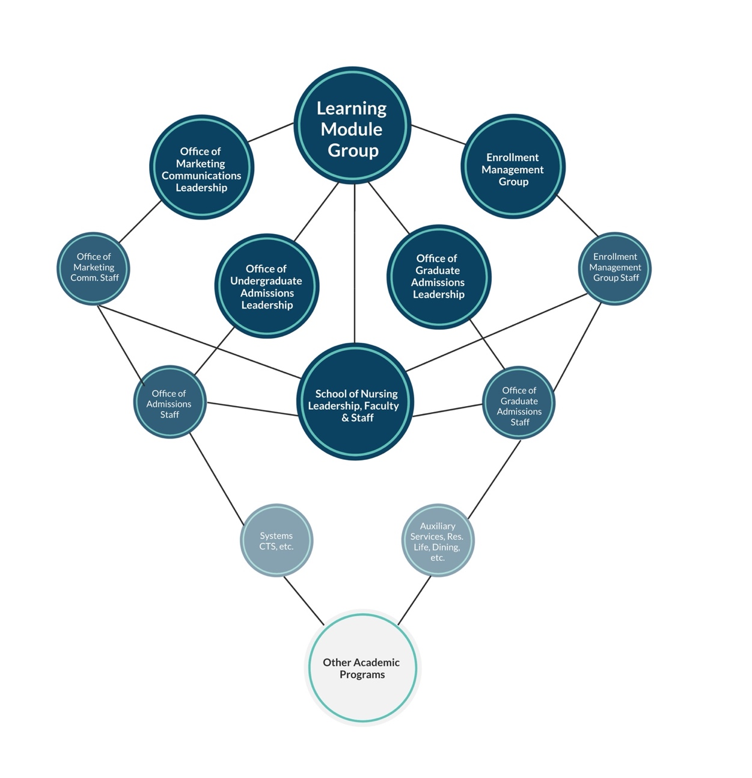

Structure of Learning Module
The module will be in the form of a workshop series, meeting twice a month for one semester, for a total of eight meetings. Turning to social presence theory when creating the structure of the learning module, Margolis, et al., (2016) makes the compelling case that face-to-face communication allows for the most social presence and “underscores how and why perceptions of authentic social interaction are essential for effective communication and learning.” Therefore, all workshop sessions will be conducted in-person. Early sessions will be comprised mainly of learning as much about Generation Z as possible, hosting guest speakers and other potential experts. As collaborative learners (Barkley, et al., 2014) the group will be divided into groups of two to three participants who will research information on both Gen Z and instructional technology outside of workshop meetings. This workshop structure is supported by the social constructivist learning theory, believing that deeper learning is a social process through which the learner internalizes knowledge obtained through social interaction (Shawa, 2020, p. 195.) [ISTE Standard 3]
The latter part of the workshop series will consist of researching the best technologies available to use in the recruitment process, and coming to an agreement on which technologies make the most sense to use. Webster (2017, p. 28) discusses that using technology for the sake of using technology is not the most an effective use of time or financial resources; however, technology could be used as a tool to accomplish goals, as opposed to being the central focus and working backwards to make goals fit to the technology. With this in mind, the workshop will concentrate on developing a plan, given all that the group will understand about Gen Z and technology, and then decide which technologies to employ [ISTE Standard 2]. Once the appropriate technology is agreed upon, the group will evaluate current technology resources, and the best methods to acquire resources that neither the School nor University possess.

Workshop Schedule
Session 1: Introduction to the group, and to Generation Z; various speakers and
researchers conduct presentations;
Session 2: Investigation of various technologies; technology leaders within the
School, the University as well from outside present. Subgroups of 2-3
students established with some asked to research Gen Z, others asked to research possible technologies to employ in recruitment process, and others to look at what other colleges and universities are doing;
Session 3: Borrowing from reflectivity, (Shawa, 2020, p. 197) subgroups present
research findings and make connections between each area researched.
Session 4: Develop strategies for recruitment. Subgroups asked to evaluate various
recruitment techniques and make recommendations based upon the shared
knowledge of Gen Z and current technologies;
Session 5: Group discusses strategies and techniques and agree to a plan to move
forward, including a timeline to implement; Discuss with the Dean of the
School of Nursing to keep her informed and to build eventual buy-in for
the plan. [ISTE Standard 2a]
Session 6: Create content for the agreed upon plan (writing messages for the various
strategies, such as digital marketing, customized engagement, videos, etc.)
Session 7: Budgets discussed for acquiring technology as well as “paid” marketing, if
applicable; Discuss proposed budget with the Dean of the School of
Nursing, and ask her to assist in creating buy-in from senior leadership
(department heads, vice presidents, the provost, etc.) [ISTE Standard 2d]
Session 8: Create systems and processes, and set launch timelines for the various plans. An example would be to adjust the CRM (customer relationship manager) to new parts of the process, or different codes programmed to leverage data differently. Agree upon the appropriate personnel to oversee various parts of the plan, and create contingencies for places in which the plan must be adjusted. [ISTE Standard 4)

Measuring Results
Measuring the outcomes of the learning module will be important, and should allow for adustments in the workshop from session to session to “course correct” as the group works together.
- The first measurement of succes for the learning module will be the level of buy-in the learning module achieves within the intial group participating in the workshop sessions. Was the learning module successful in making the case that changing the recruitment process for the School of Nursing is necessary?
- The next measure of success will be the resulting recruitment and communication plan which will come out of the session, and the level of buy-in from the Dean and departmental leadership for the plan.
- The final indicator of success is whether or not student enrollment increases.

School and University Buy-In
Borrowing from Margolis (2016, p. 615) regarding complex adaptive systems, in this case an academic school nested within a university, “. . . these entities can only be influenced, rather than controlled or oversimplified.” To support the workshop series, coalition building will begin through meeting with the School of Nursing Executive Committee, which is made-up of Assistant and Associate Deans and chaired by the Dean. During the meeting, the committee will be briefed on the characteristics of the college-age population and the direction of enrollment management. Data from the School of Nuring and the University will be used to support the perceived direction of School enrollment. Assuming the Executive Committee wishes to move forward with the workshop series and shares the vision outlined in the presentation, assistance from committee members to further the waive of influence will be requested. Although Margolis (2016, p. 618) was discussing teacher leadership development, he provides valuable insight into influence, which is applicable in this instance, that “positional maps identify the range of positions, agendas, and/or power flows that are present, or not present, in the situation” and “ . . .to consider all the actors, organizational contexts, and commitments that influence the situation . . .” In this context, the Dean and other committee members will be enlisted to involve the department leaders of the Office of Marketing and Communication, the Enrollment Management Group, and the Office of Admissions to involve staff members of their departments.

Limitations
Some leaders within the school, and perhaps other departments, will not be open to change. Although it is difficult to know the agendas of everyone involved, some of the decision makers and key stakeholders may be the very people who made decisions which currently drive the recruitment and admission process. Others may be resistant to changing plans or to utilize new technology in recruitment because current methods are producing results, or they may fear adapting to different technologies if it would be required of them.
Another limitation may be financial. If the group identifies technologies which the School or University cannot afford or do not believe can be justified, that part of the plan may need to be altered. The workshop group will consider limitations and contingency plans in their sessions.

CONCLUSION
Since the learning module is centered on the School of Nursing at Duquesne, conclusions drawn are primarily for that program. Other programs will have strenghts and weaknesses, and some of the takeaways from the workshop sessions could inevitably benefit other departments/schools at Duquesne.
The School of Nursing offers many degrees that will appeal to Generation Z students, and most nurising programs involve a pratical, hands-on clinical experience. The profession also fits Gen Z because nurses are in high demand, so the job outlook appears to be strong. Prior to Covid-19 pandemic, there was a national shortage of over one million nurses (Krans, 2017). The need for nurses has grown exponentially in the last ten months, as the pandemic grows to record highs (McLemon, 2020). In addition, the nursing profession will appeal to the sense of ethics, compassion, and collaborative spirit of Gen Zers. With some adjustments to the marketing and recruitment strategies of the School, the future of the profession looks bright for years to come.

REFERENCES

Barkley, E., Major, C., & Cross, P. (2014). Collaborative learning techniques: a handbook for college faculty. Vol. Second edition. Jossey-Bass.

Beard, H. (2019, September 4). What makes Generation Z different. [Video file]. https://www.youtube.com/watch?v=qyCn3APagyU

Devereux, L., Melewar, T. C., Dinnie, K., & Lange, T. (2020). Corporate identity orientation and disorientation: A complexity theory perspective. Journal of Business Research, 109, 413-424. https://doi.org/10.1016/j.jbusres.2019.09.048

Dorsey, J., & Villa, D. (2020). Zconomy: How Gen Z will change the future of business—and
what to do Aabout it. Harper Collins

Hoffower, H. (2020) GenZ is set to take over the economy in a decade, despite potentially losing
$10 trillion in earnings because of the pandemic. Business Insider.
https://www.businessinsider.com/gen-z

Jenkins, R. (2019). The Generation Z guide: the complete manual to understand recruit, and
lead the next generation. Ryan Jenkins Publishing

Krans, B. (2017). The nursing shortage: where are we going to find 1 million new nurses in the
next five years? Healthline. https://www.healthline.com/health-news/where-are-we-going-to-find-1-million-new-nurses-in-the-next-five-years-092815

Kolarova, I., Bediova, M., & Rasticova, M. (2016). Factors Influencing Motivation of
Communication Between Generation Y, Generation X and Baby Boomers. Proceedings of the European Conference on Knowledge Management, 476–484

Margolis, J., Durbin, R., & Doring, A.(2017).The missing link in teacher professional
development: student presence. Professional Development in Education, 43(1), 23-35.

Margolis, J. (2020). The semiformality of teacher leadership on the edge of chaos. Harvard
Educational Review, 90(3), 397-418. https://doi.org/10.17763/1943-5045-90.3.397

McLernon, L. (2020). COVID-related nursing shortages hit hospitals nationwide. Center for
Infectious Disease Research and Policy. https://www.cidrap.umn.edu/news-perspective/2020/11/covid-related-nursing-shortages-hit-hospitals-nationwide

Osei-Frimpong, K., & McLean, G. (2018). Examining online social brand engagement: A social
presence theory perspective. Technological Forecasting and Social Change, 128, 10-21. https://doi.org/https://doi.org/10.1016/j.techfore.2017.10.010

Rue, P. (2018). Make way, millennials, here comes Gen Z. About Campus: Enriching the Student
Learning Experience, 23(3), 5-12. https://doi.org/10.1177/1086482218804251

Shawa, L. B. (2020). Advancing the scholarship of teaching and learning using learning theories
and reflectivity. Center for Educational Policy Studies Journal, 10(1), 191-208. https://doi.org/10.26529/cepsj.298

Webster, M. D. (2017). Philosophy of Technology Assumptions in Educational Technology
Leadership. Educational Technology & Society, 20 (1), 25–36.

