**Success Predictors of Duquesne University School of Nursing Students enrolled from Spring 2017 through Fall 2021**

**Sarah Alzahrani, Scott Copley, & Alicia Segura Pinto**

Duquesne University

GREV 510 - Statistics I

Dr. Nandini Bhowmick

December 1st, 2021

1. **INTRODUCTION**

The School of Nursing at Duquesne University wishes to learn more about student performance in the Family Nurse Practitioner program. Historically, the school has believed that using the last 60 credits (L60) in a student’s undergraduate program (BSN – Bachelor of Science in Nursing) may be a predictor of success in the Master of Science - Family Nurse Practitioner program.

As Mthimunye and Daniels (2019) highlight, “understanding the factors that predict the academic performance of nursing students is one of the major goals of universities and schools of nursing globally (p. 200). However, this is not an easy job for universities to do. Our study focuses on one aspect that is crucial for us to learn about student performance in the Family Nurse Practitioner program.

This project looks at data of all accepted and enrolled students from Spring 2017 through Fall 2021, which also coincides with the development of a relationship with Pearson, a third-party online program management (OPM) company. For the sake of the study, the school considers students to be “successful” if they have graduated or are currently making expected progress in the program. Conversely, the school considers students “unsuccessful” if they have been dismissed or withdrawn for various reasons and did not return to school. As Krumrei-Mancuso et al. (2013) state: “students who terminate their education before graduation lose the time and finances that they have invested in the educational process without gaining benefits of a degree” (p. 247)

1. **RESEARCH QUESTIONS AND HYPOTHESES**

**2.1. Research questions**

In researching predictors of success in the nursing program at Duquesne University, our team considered the following research questions:

**Research question 1**: Does the L60 credit GPA of the BSN program correlate to average student performance and success?

**Research question 2**: Is the overall average GPA of a student a better predictor of student performance than the last 60 GPA?

**Research question 3**: Are the L60 GPA and the overall GPA a similar predictor of performance?

**2.2. Hypotheses**

After considering our research questions, the following hypotheses were presented:

**Null hypothesis**: there is no significant difference between the L60 GPA and the overall GPA in predicting success in the program.

**Alternative hypothesis**: the L60 GPA is a better predictor of success in the program than the overall GPA.

1. **METHODOLOGY**

**3.1. Sample**

The sample was made up of 334 students from the School of Nursing that were enrolled in the Family Nurse Practitioner program from Spring 2017 through Fall 2021 at Duquesne University (N = 334). Our female population was made up of 311 are female (N = 311) and 23 are male (N = 23).

Our team selected five different variables, two of which were categorical variables (female-male), and three were continuous variables (successful-active-graduate), which considered students’ status in the Nurse Practitioner program at Duquesne University. Our categorical variables are presented in the following table:

**Table 1**

*Sample of female and male students at the School of Nursing (2017-2021)*

**Name Description**

Gender Student's gender (Nominal)

*Value Label*

1 Female (N = 311)

2 Male (N = 23)

**Table 2**

*Percentages of the student population genders*

**Descriptive statistics for each variable**

**The Frequency of the Categorical Variables**

***Gender***

A total of 311 out of 334 students (93.1 %) were female, while 23 were male (6.9%)

|  |  |  |  |  |  |
| --- | --- | --- | --- | --- | --- |
|  | | | | | |
|  | | Frequency | Percent | Valid Percent | Cumulative Percent |
| Valid | Female | 311 | 93.1 | 93.1 | 93.1 |
| Male | 23 | 6.9 | 6.9 | 100.0 |
| Total | 334 | 100.0 | 100.0 |  |

Additionally, our team made reference to the continuous variables (successful-active-graduate) throughout this paper under the names of “L60 BSN GPA,” which covers the last 60 credits that a student earned in their grade point average through their Bachelor’s of Science degree (interval). Moreover, our team used the term “BSN GPA” to make reference to the overall grade point average that a student earned through their Bachelor’s of Science (interval), covering all the credits earned in the degree. Finally, our last variable under this group included the grade point average that a student currently has once in the graduate program or Master’s Degree (interval), which is referenced as “Gr Lvl GPA.”

**Table 3**

*Summary of student’s status at the School of Nursing (2017-2021)*

**Students' status (Nominal)**

*Value Label*

1 Successful

2 Active

3 Graduate

**Table 4**

*Histogram of female and male students at the School of Nursing (2017-2021)*

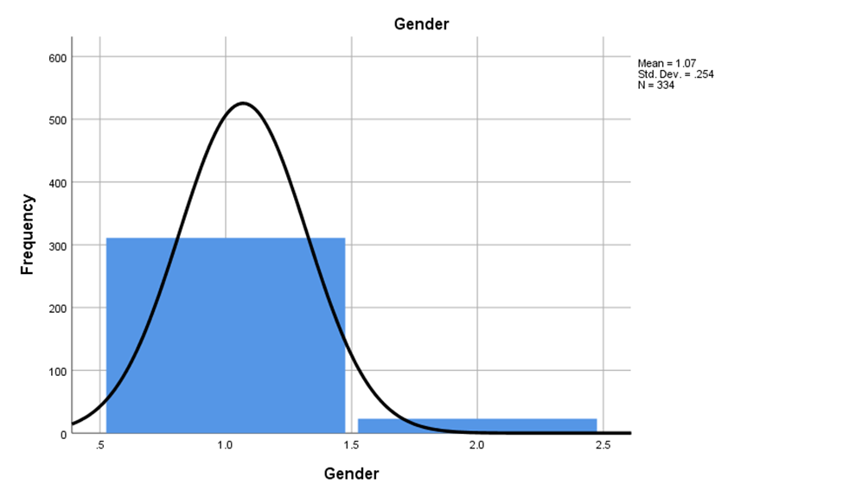

***3.1.1. Summary Status***

The number of students who did not complete the program is 115 (N = 115), which was the 34.4%, the total number of students who are still active in the program is 145 (N = 145), a 43.4%, and the number of graduated students is 74 (N = 74), a 22.2% of students.

**Table 5**

|  |  |  |  |  |  |
| --- | --- | --- | --- | --- | --- |
|  | | | | | |
|  | | Frequency | Percent | Valid Percent | Cumulative Percent |
| Valid | Not successful | 115 | 34.4 | 34.4 | 34.4 |
| Active | 145 | 43.4 | 43.4 | 77.8 |
| Graduated | 74 | 22.2 | 22.2 | 100.0 |
| Total | 334 | 100.0 | 100.0 |  |

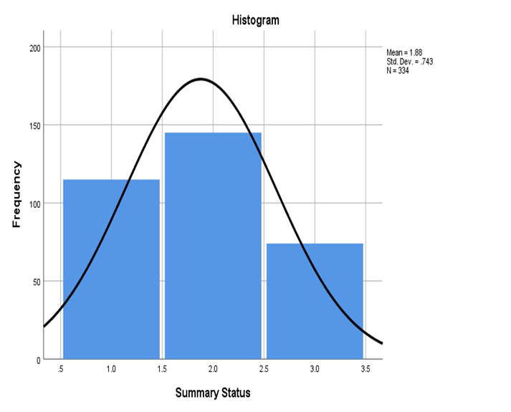

**Descriptive Statistic of the Continuous Variables**

The table depicts the descriptive statistics for the three GPAs received by students. Master's degree students have a 3.53 average GPA, which is higher than the other GPAs. The GPAs students received on their last 60 credits, and their bachelor's degrees are similar, with both GPAs averaging 3.47. The last 60 credits GPA has the lowest standard deviation (.25), indicating that students' GPAs are more consistent because they are less spread out from the mean. Students received a minimum of 2.64 in BSN GPA, a minimum of 2.00 in Gr Lvl GPA, and a minimum of 2.95 in L60 GPA, with a maximum of 4 in all of them.

|  |  |  |  |  |  |  |
| --- | --- | --- | --- | --- | --- | --- |
|  | | | | | | |
|  | N | Range | Minimum | Maximum | Mean | Std. Deviation |
| BSN GPA | 334 | 1.36 | 2.64 | 4.00 | 3.53 | .27 |
| Gr Lvl GPA | 334 | 2.00 | 2.00 | 4.00 | 3.47 | .31 |
| L60 | 334 | 1.05 | 2.95 | 4.00 | 3.47 | .25 |
| Valid N (listwise) | 334 |  |  |  |  |  |

**4. RESULTS AND ANALYSIS**

**Correlation**

The table revealed that the variables have a statistically significant relationship. As seen, there is a significant but weak correlation between the BSN GPA and the Grad Level GPA of 0.159, and a stronger but still weak correlation between the L60 BSN GPA of 0.227.

|  |  |  |  |  |
| --- | --- | --- | --- | --- |
|  | | | | |
|  | | BSN GPA | Gr Lvl GPA | L60 |
| BSN GPA | Pearson Correlation | 1 | .159** | .677** |
| Sig. (2-tailed) |  | .003 | .000 |
| Sum of Squares and Cross-products | 25.554 | 4.624 | 15.842 |
| Covariance | .077 | .014 | .048 |
| N | 334 | 334 | 334 |
| Gr Lvl GPA | Pearson Correlation | .159** | 1 | .227** |
| Sig. (2-tailed) | .003 |  | .000 |
| Sum of Squares and Cross-products | 4.624 | 32.920 | 6.016 |
| Covariance | .014 | .099 | .018 |
| N | 334 | 334 | 334 |
| L60 | Pearson Correlation | .677** | .227** | 1 |
| Sig. (2-tailed) | .000 | .000 |  |
| Sum of Squares and Cross-products | 15.842 | 6.016 | 21.420 |
| Covariance | .048 | .018 | .064 |
| N | 334 | 334 | 334 |
| **. Correlation is significant at the 0.01 level (2-tailed). | | | | |

**Scatterplot**

The scatterplot for the L60 (independent variable) and Gr Lvl GPA (dependent variable) data shows a weak positive and linear relationship between the two variables due to the points being widely scattered about a line. Student GPA on the last 60 credits of their Bachelor's degree is a small positive predictor of student success in their Master's degree.

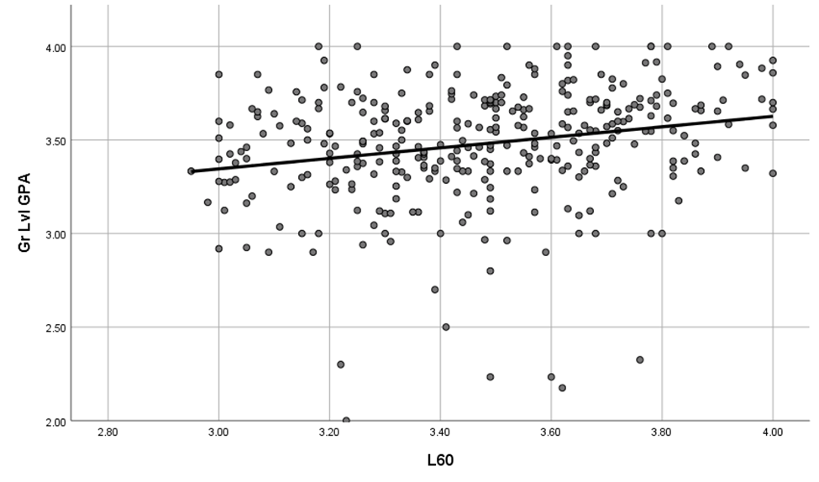

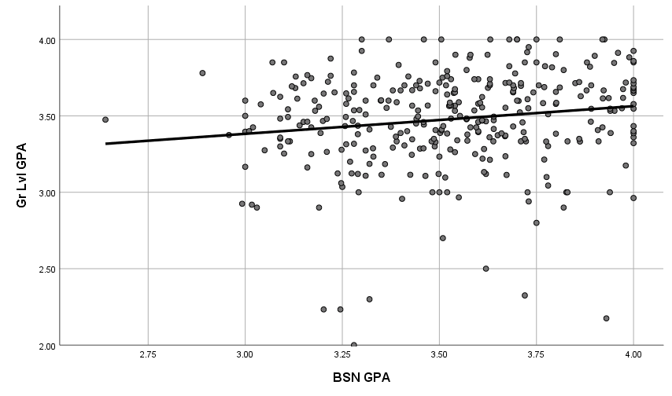

**One Sample Z-test**

We also used the Z-test to determine whether there was a statistically significant difference in GPA between graduate students at Duquesne Nursing School and other graduate nursing students. The average GPA (M = 3.47) of 334 Duquesne graduate students was compared to the average GPA (M = 3.00, SD =.25) of other grade nurse students. A Z-test revealed that the z statistic was 34.358, and the P-value was .0001, indicating that Duquesne's nursing school student GPA was significantly different from other graduate nursing students' GPA.

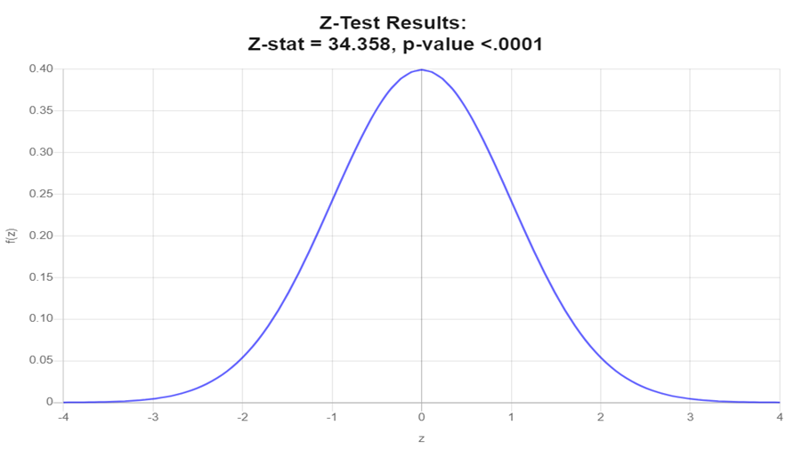

**5. CONCLUSIONS**

A Pearson correlation coefficient was computed to assess the linear relationship between the L60 and BSN GPA. There was a weak positive correlation between the two variables, r (0.227), p = .000. We also looked at the linear relationship between the BSN GPA and the Grad Level GPA and calculated a Pearson correlation coefficient. Between the two variables, there existed a weak positive correlation (r (0.15), p =.003). Based on this result, we failed to reject the null hypothesis, since the p-values for the L60 BSN GPA and the BSN GPA were both less than the significant level (0.01), indicating no significant difference between the L60 GPA and the overall GPA in predicting program success as both could predict students' success..

Additionally, the null hypothesis was rejected based on the Z-test results. There was a statistical significant difference between the population mean and the sample mean based on the alpha level of .05 significance level. The P-value was .0001, indicating that the nursing school student GPA at Duquesne was significantly different from the GPAs of other graduate nursing students.

**6.** **LIMITATIONS AND FURTHER RESEARCH**

Even though our study merely focused on Duquesne University nursing students being successful, active, and graduated, we could expand this study by adding some other factors that predict academic performance and success of graduate nursing students. Mthimunye and Daniels (2019) analyzed some of these factors in relation to nursing students, and categorized them into six groups: student profile characteristics, student affective factors, academic factors, environmental factors, academic outcomes, and psychological outcomes (p. 209).

Additionally, as Mthimunye and Daniels (2019) state, “assessments should be held to examine emotional intelligence, self-control, resilience, academic skills and motivational characteristics of students prior to, or at the beginning of, the programme to identify at-risk students and those who are extrinsically motivated, so that their progress can be monitored” (p. 217)

**References**

Krumrei Mancuso, E., Newton, F., Kim, E., & Wilcox, D. (2013). Psychosocial Factors Predicting First-Year College Student Success. *Journal of College Student Development, 54*, 247-266.<https://doi.org/10.1353/csd.2013.0034>

Mthimunye, K., & Daniels, F. M. (2019). Predictors of academic performance, success and retention amongst undergraduate nursing students : a systematic review. *South African Journal of Higher Education, 33*(1), 200-220.<https://doi.org/doi:10.20853/33-1-2631>